**Front-end**

1. Routes can be defined in separate routes file.

1. Job service

Method name “UploadFile” is not clear though it is handling specific task.

Also, three methods in job service class have duplicate code.

1. Employee Service, Certification Service

Used ‘Any’ with promise.

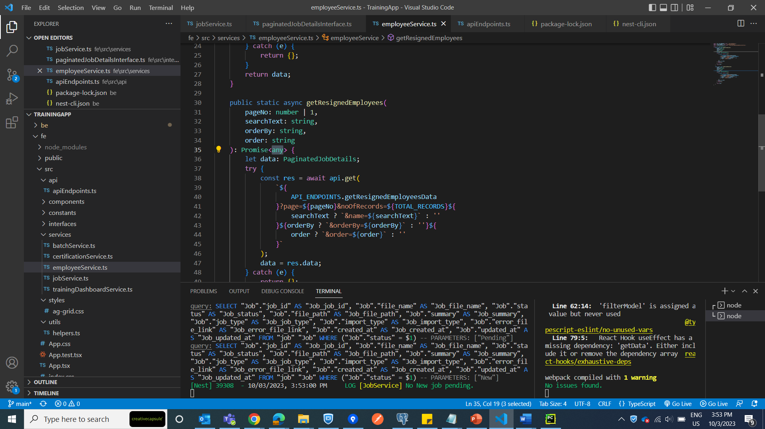

1. Raw data Employees tablehas Cryptic column headings: Doj, Curr Grade, Curr Location

1. There are multiple warning in terminal window after starting the application